Name:Ch.Shivamani H.No:2303A51806 Batch:26
SCHOOL OF COMPUTER SCIENCE AND ARTIFICIAL INTELLIGENCE |  |  |  |  | DEPARTMENT OF COMPUTER SCIENCE ENGINEERING
Program Name: B. Tech |  |  |  | Assignment Type: Lab |  |  | Academic Year:2025-2026
Course Coordinator Name |  |  |  | Dr. Rishabh Mittal
Instructor(s) Name |  |  |  | Mr. S Naresh Kumar  Ms. B. Swathi  Dr. Sasanko Shekhar Gantayat  Mr. Md Sallauddin  Dr. Mathivanan  Mr. Y Srikanth  Ms. N Shilpa  Dr. Rishabh Mittal (Coordinator)  Dr. R. Prashant Kumar  Mr. Ankushavali MD  Mr. B Viswanath  Ms. Sujitha Reddy  Ms. A. Anitha  Ms. M.Madhuri  Ms. Katherashala Swetha  Ms. Velpula sumalatha  Mr. Bingi Raju
Course Code |  |  | 23CS002PC304 | Course Title |  | AI Assisted Coding
Year/Sem |  |  | III/II | Regulation |  | R23
Date and Day  of Assignment |  |  | Week6 – Wednesday | Time(s) |  | 23CSBTB01 To 23CSBTB52
Duration |  |  | 2 Hours | Applicable to  Batches |  | All batches
Assignment Number:11.3(Present assignment number)/24(Total number of assignments)
 | Q.No. | Question |  |  |  |  |  | Expected Time  to complete
 | 1 | Lab 11: Data Structures with AI Implementing Fundamental Data Structures using AI Assistance  Lab Objectives:  By the end of this lab, students will be able to:  - Design and implement fundamental data structures in Python using AI assistance.  - Effectively prompt AI tools (e.g., GitHub Copilot) for code generation, optimization, and documentation.  - Understand and compare core data structures: Arrays, Linked Lists, Stacks, Queues, Priority Queues, Trees, and Graphs.  - Improve code readability, efficiency, and maintainability using AI-generated suggestions.  Learning Outcomes  After completing this lab, students will be able to:  - Apply appropriate data structures to solve real-world problems.  - Analyze time and space complexity of different data structure operations.  - Use AI tools responsibly to assist (not replace) logical thinking and problem-solving.  - Validate, test, and refine AI-generated code.  Task 1: Smart Contact Manager (Arrays & Linked Lists)  Scenario  SR University’s student club requires a simple Contact Manager Application to store members’ names and phone numbers. The system should support efficient addition, searching, and deletion of contacts.  Tasks  - Implement the contact manager using arrays (lists).  - Implement the same functionality using a linked list for dynamic memory allocation.  - Implement the following operations in both approaches:  - Add a contact  - Search for a contact  - Delete a contact  - Use GitHub Copilot to assist in generating search and delete methods.  - Compare array vs. linked list approaches with respect to:  - Insertion efficiency  - Deletion efficiency  Expected Outcome  - Two working implementations (array-based and linked-list-based).  - A brief comparison explaining performance differences.  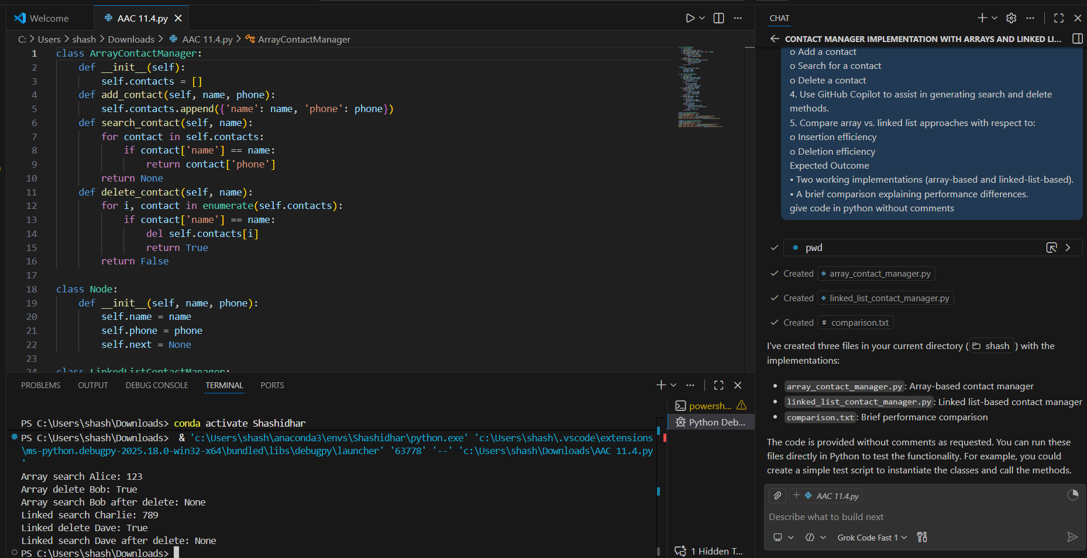  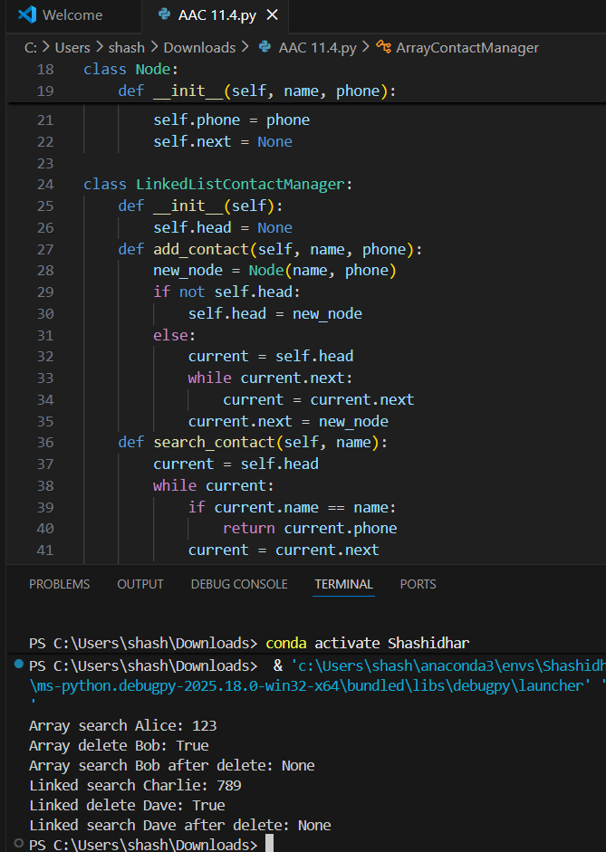  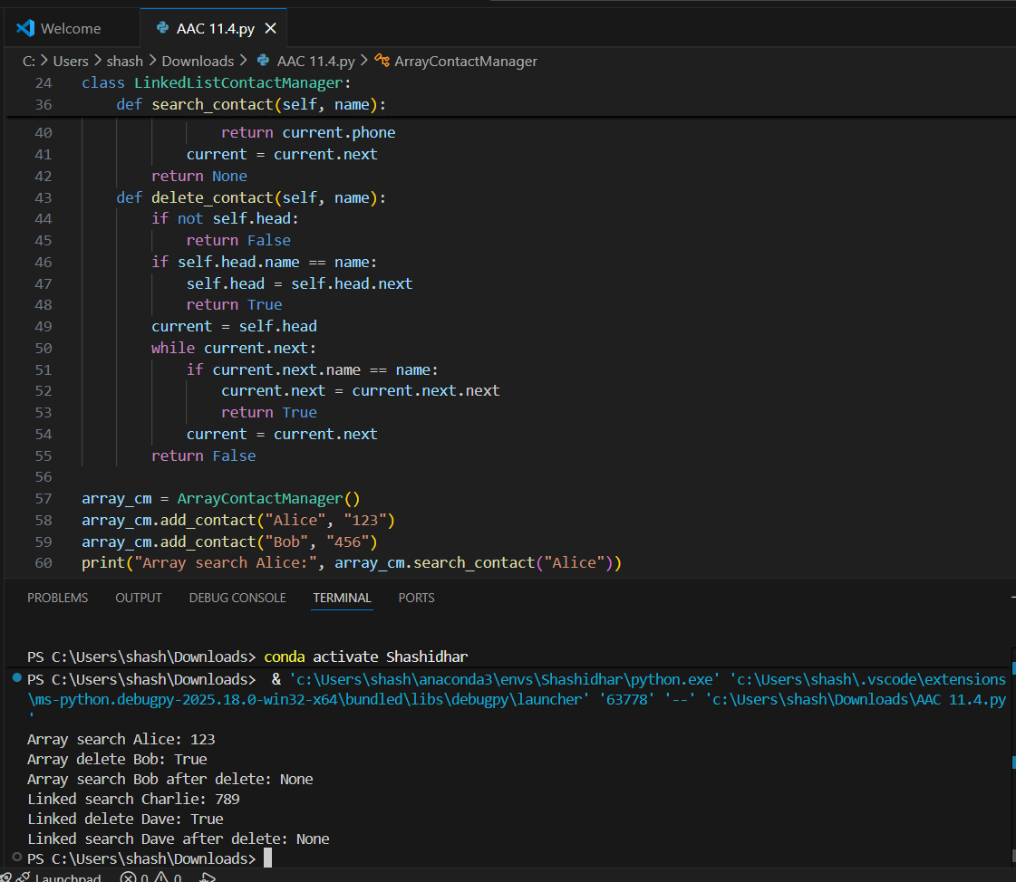  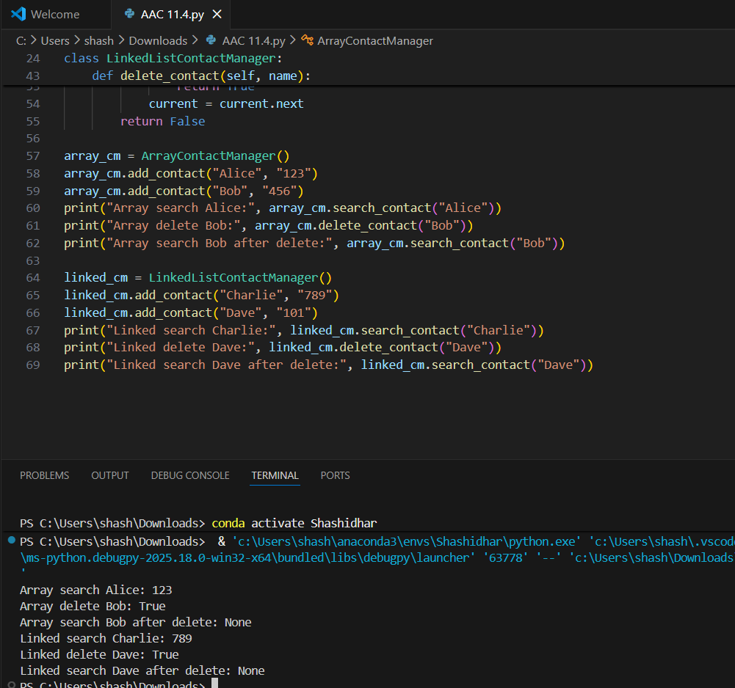  Task 2: Library Book Search System (Queues & Priority Queues)  Scenario  The SRU Library manages book borrow requests. Students and faculty submit requests, but faculty requests must be prioritized over student requests.  Tasks  - Implement a Queue (FIFO) to manage book requests.  - Extend the system to a Priority Queue, prioritizing faculty requests.  - Use GitHub Copilot to assist in generating:  - enqueue() method  - dequeue() method  - Test the system with a mix of student and faculty requests.  Expected Outcome  - Working queue and priority queue implementations.  - Correct prioritization of faculty requests.  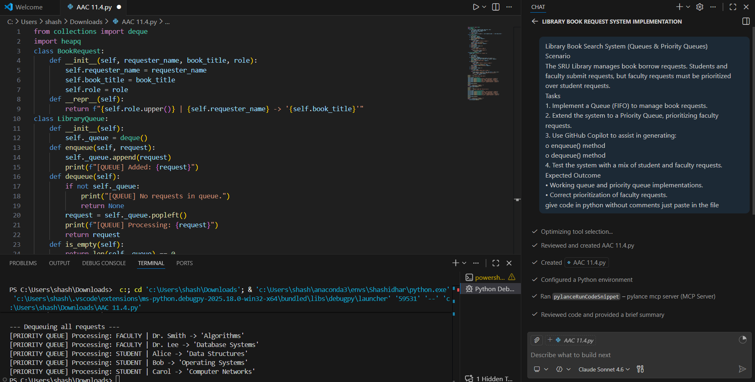  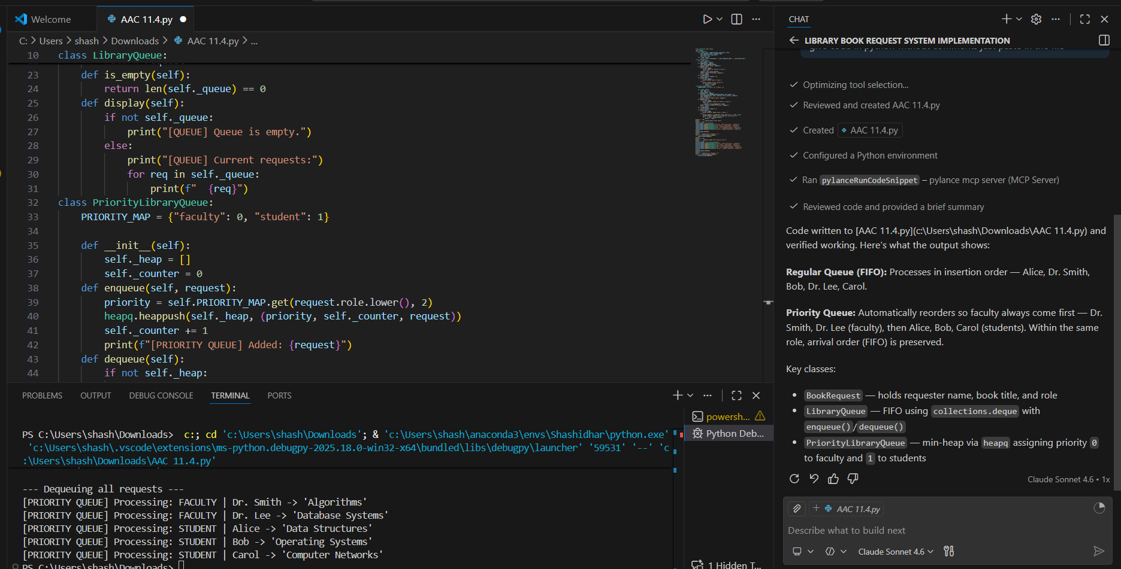  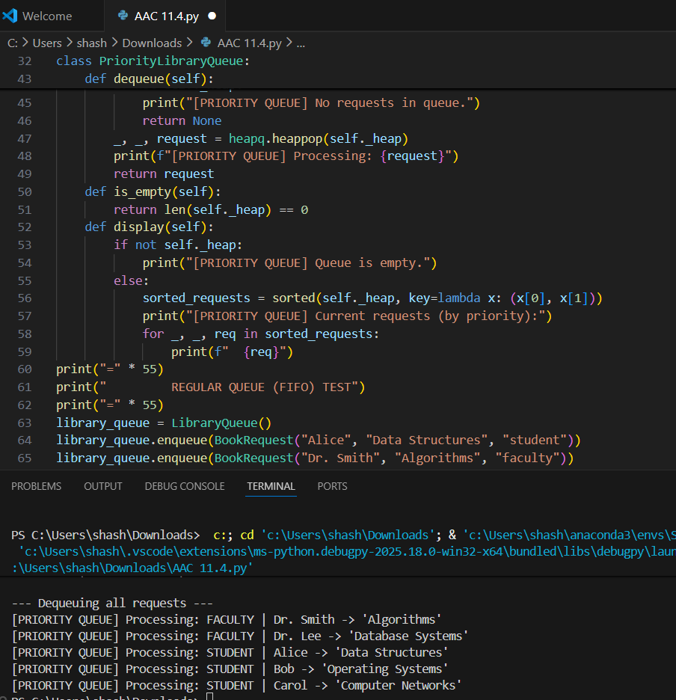  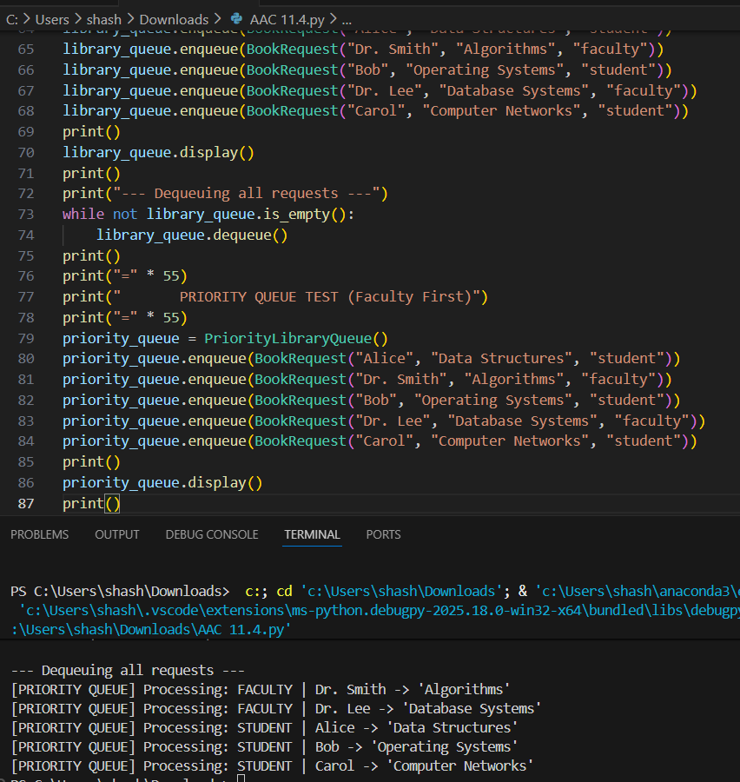  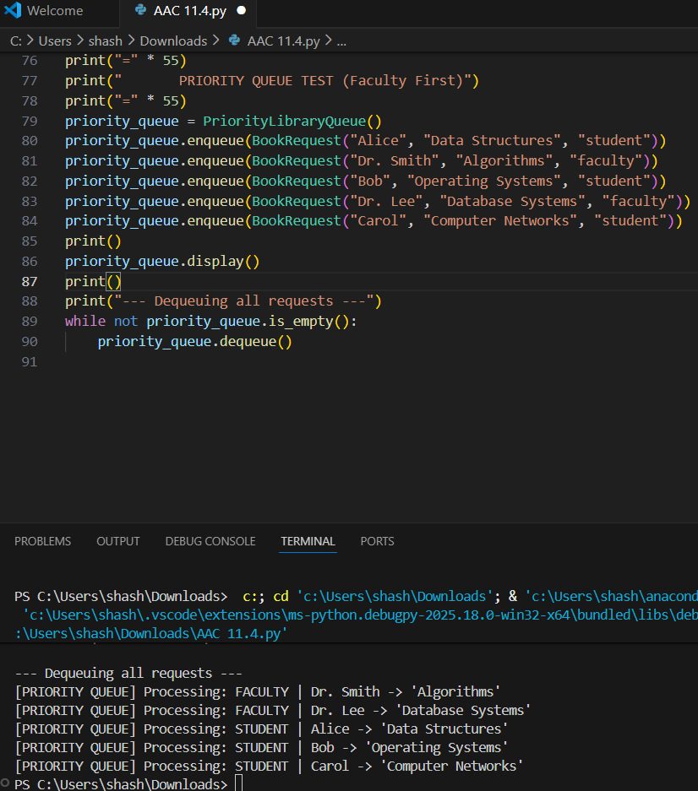  Task 3: Emergency Help Desk (Stack Implementation)  Scenario  SR University’s IT Help Desk receives technical support tickets from students and staff. While tickets are received sequentially, issue escalation follows a Last-In, First-Out (LIFO) approach.  Tasks  - Implement a Stack to manage support tickets.  - Provide the following operations:  - push(ticket)  - pop()  - peek()  - Simulate at least five tickets being raised and resolved.  - Use GitHub Copilot to suggest additional stack operations such as:  - Checking whether the stack is empty  - Checking whether the stack is full (if applicable)  Expected Outcome  - Functional stack-based ticket management system.  - Clear demonstration of LIFO behavior.  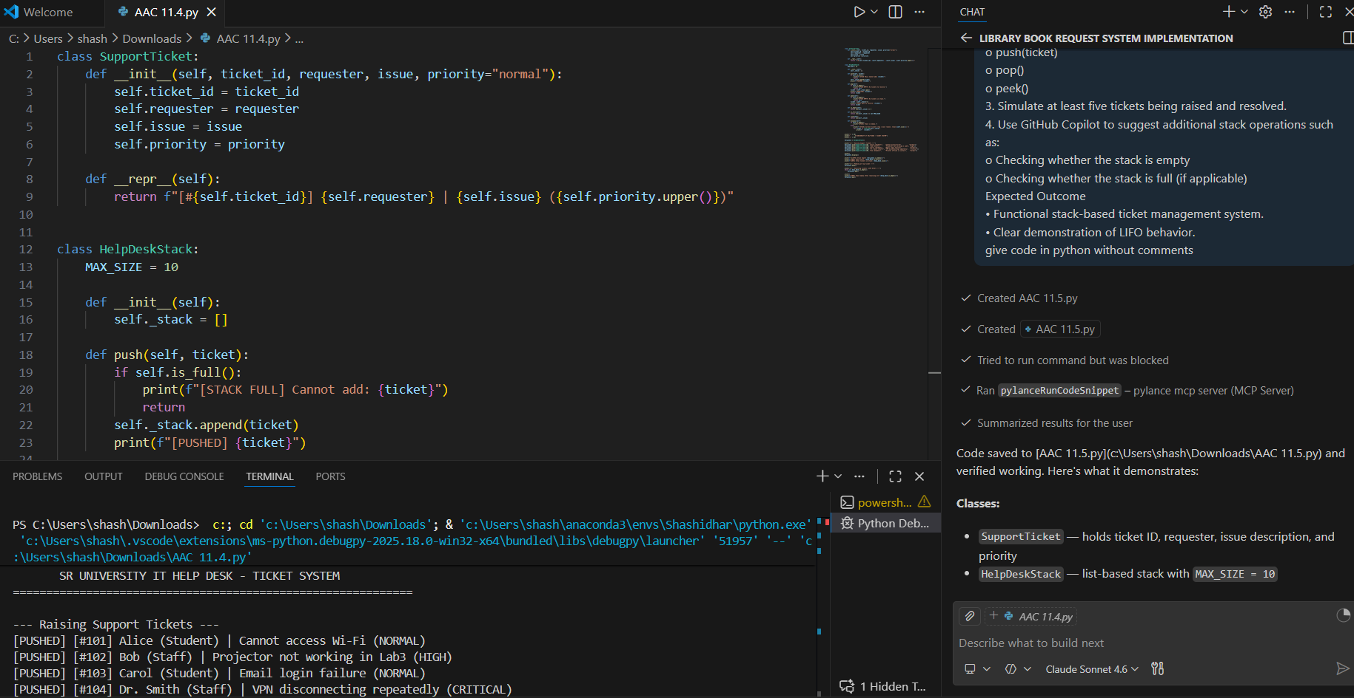  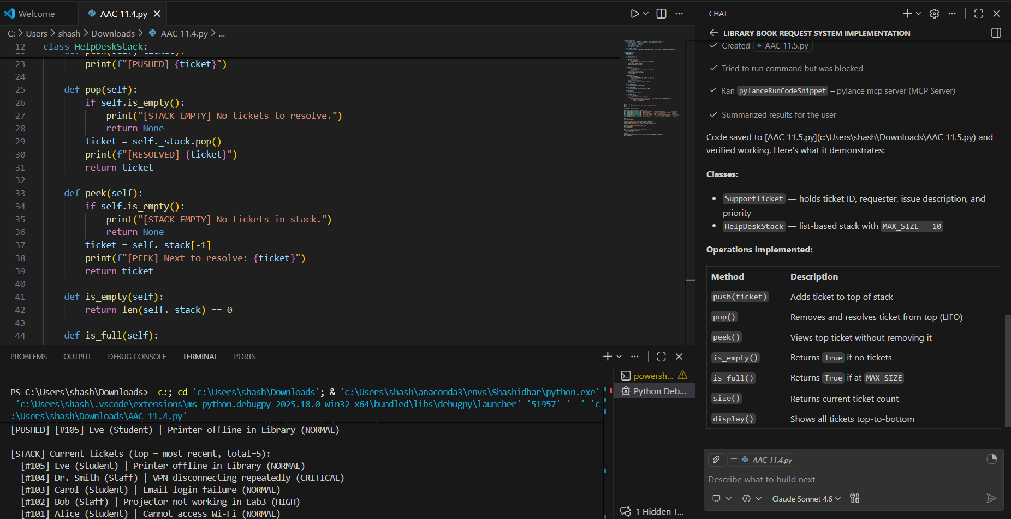  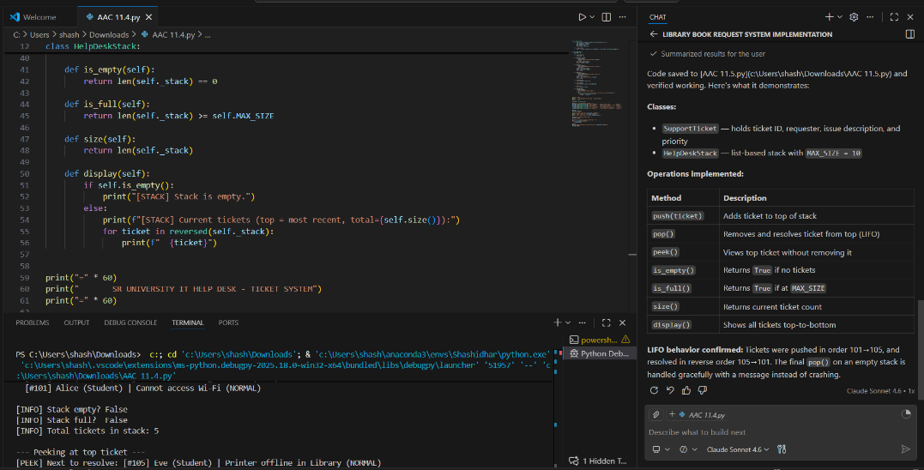  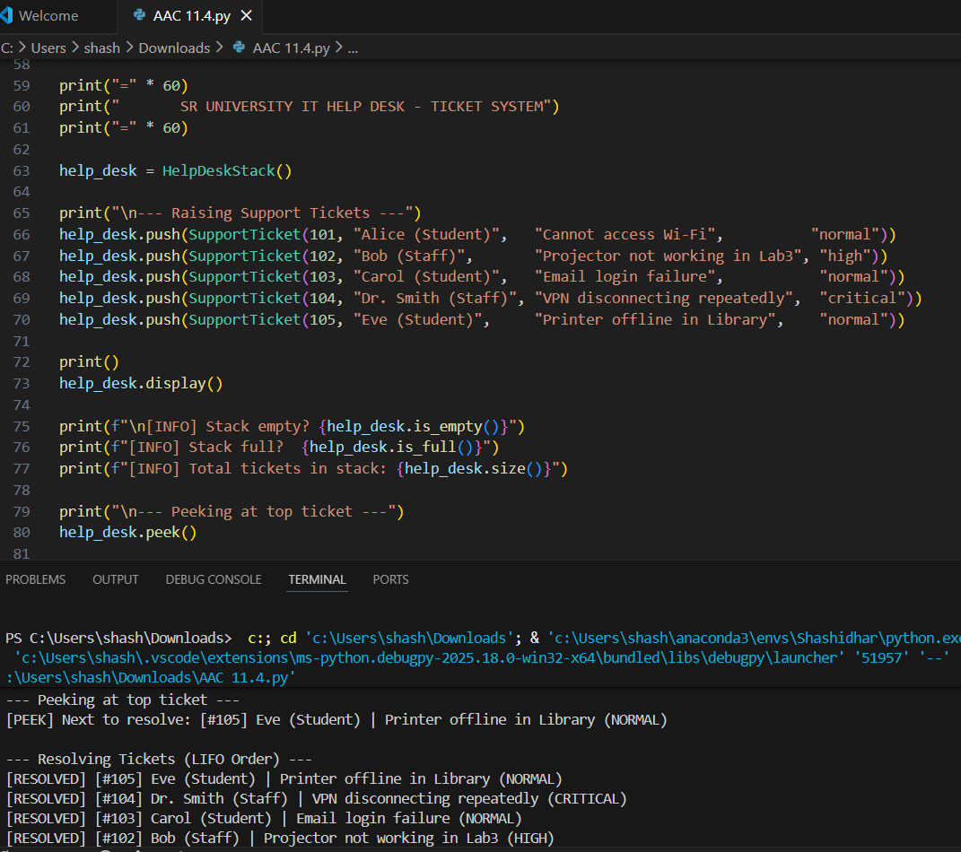  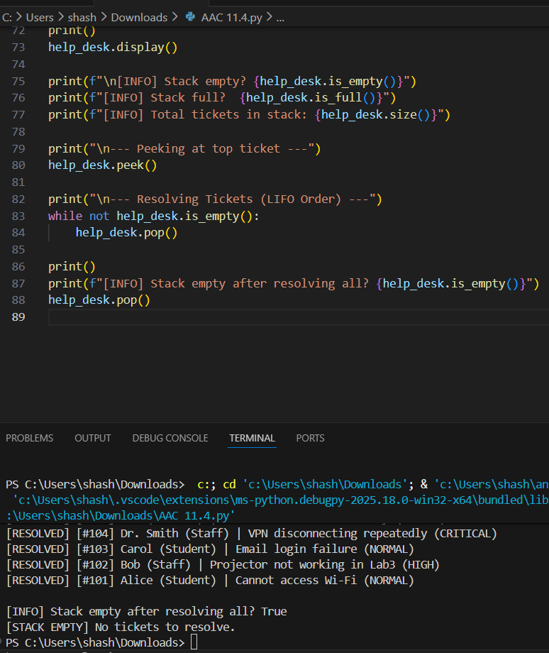  Task 4: Hash Table  Objective  To implement a Hash Table and understand collision handling.  Task Description  Use AI to generate a hash table with:  - Insert  - Search  - Delete  Starter Code  class HashTable:  pass  Expected Outcome  - Collision handling using chaining  - Well-commented methods  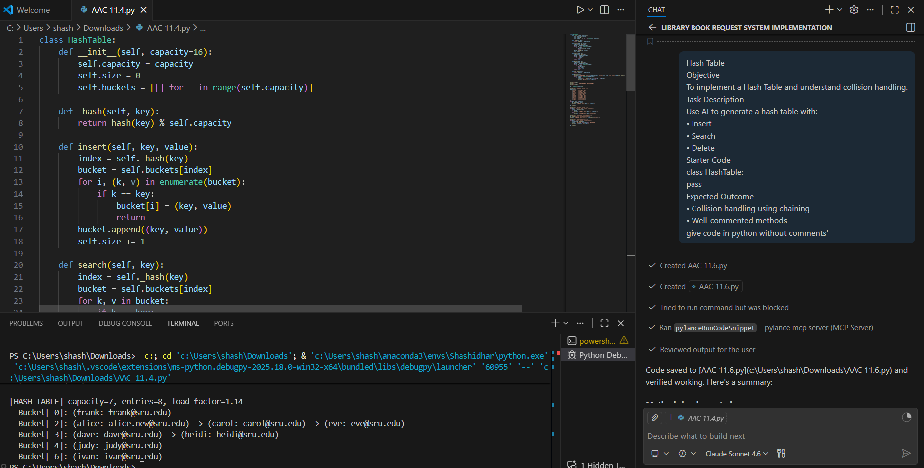  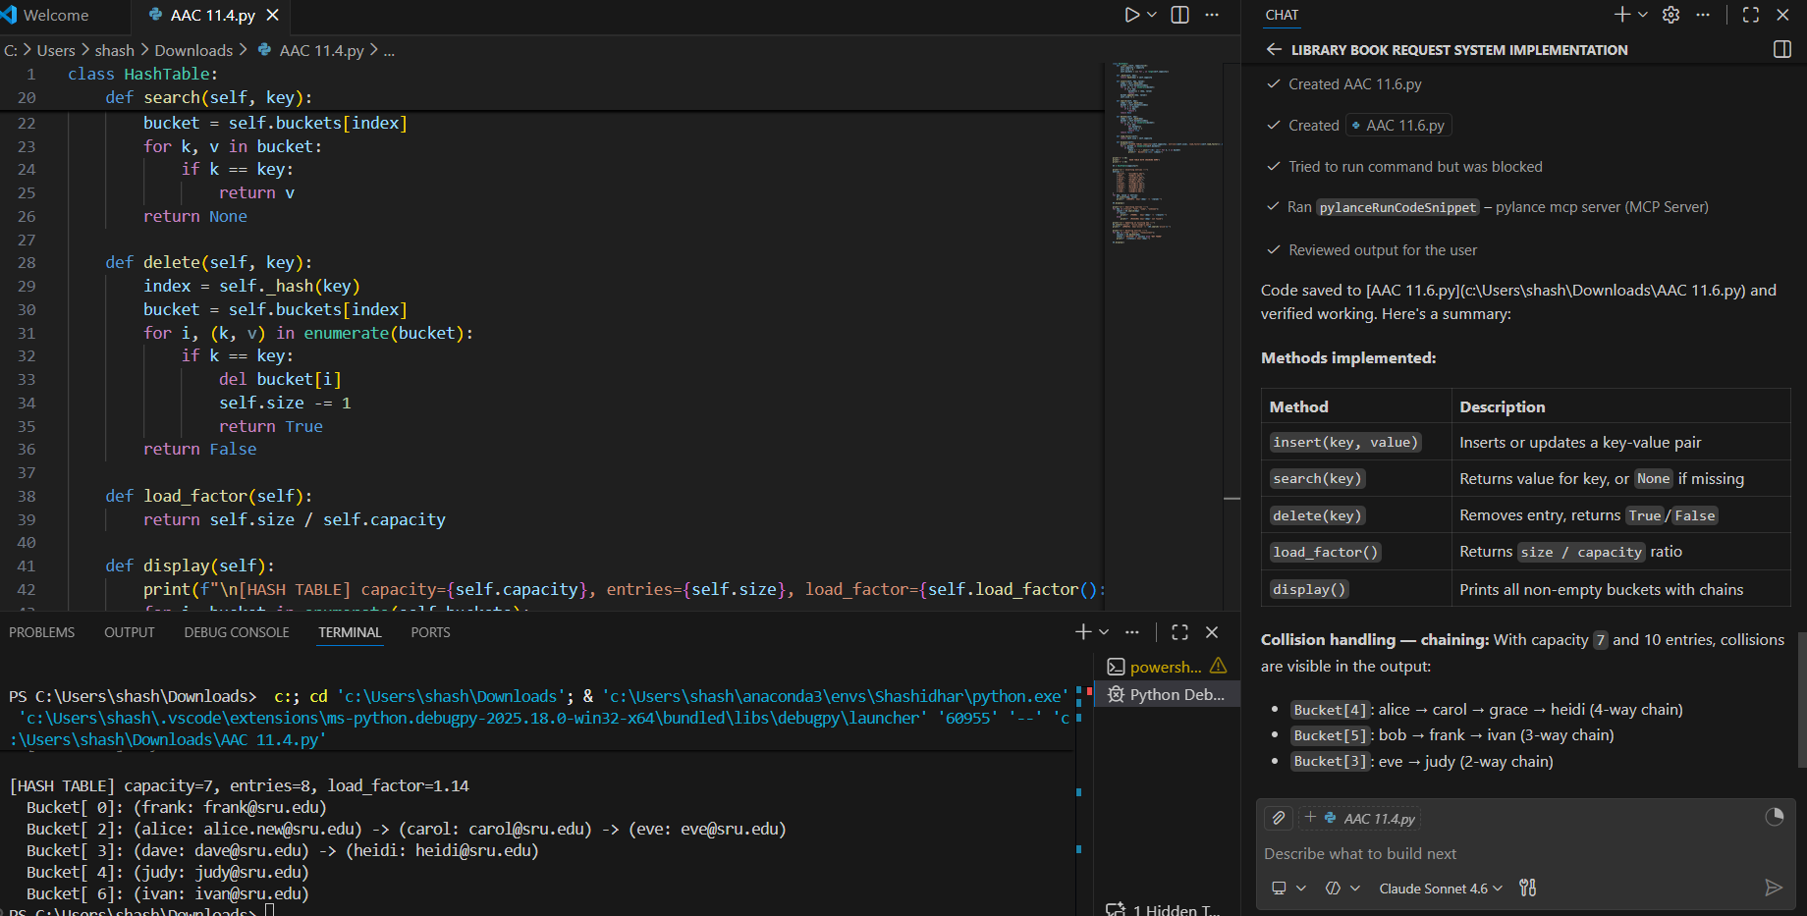  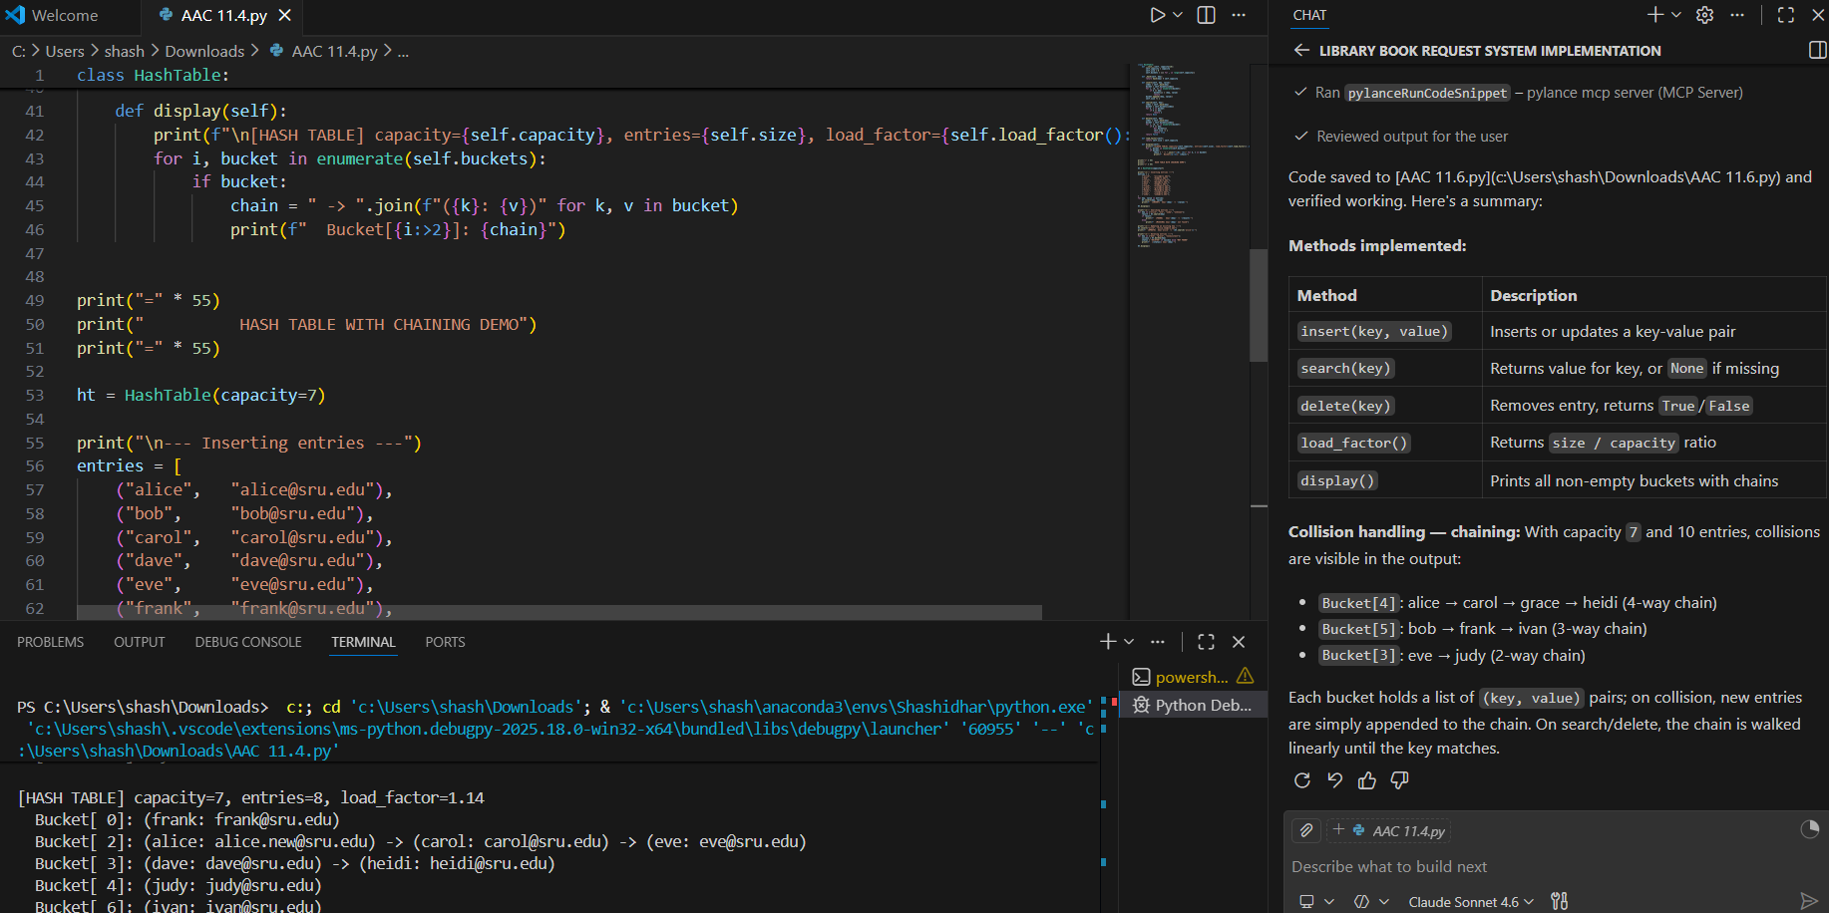  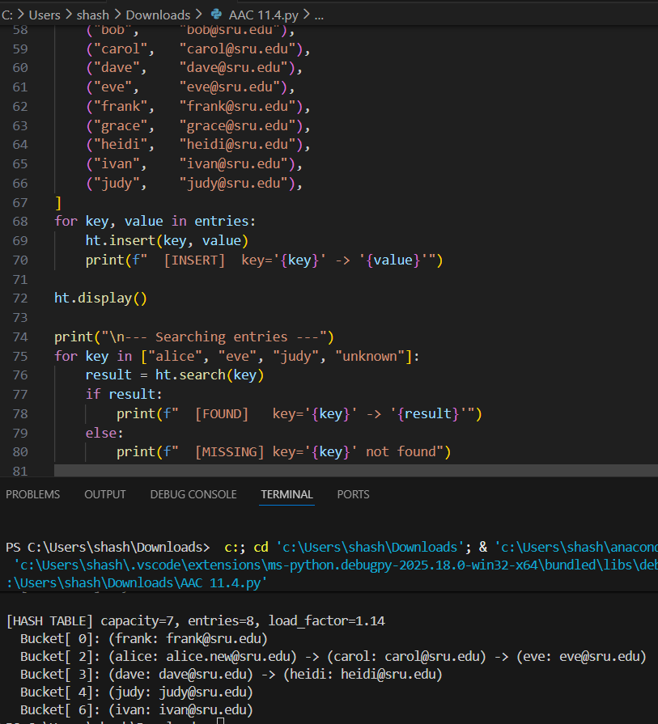  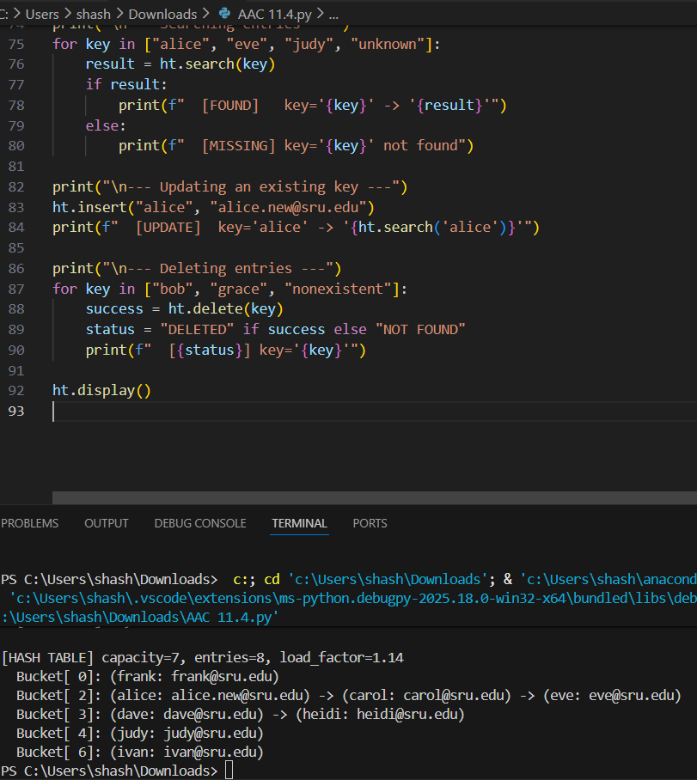  Task 5: Real-Time Application Challenge  Scenario  Design a Campus Resource Management System with the following features:  - Student Attendance Tracking  - Event Registration System  - Library Book Borrowing  - Bus Scheduling System  - Cafeteria Order Queue  Student Tasks  - Choose the most appropriate data structure for each feature.  - Justify your choice in 2–3 sentences.  - Implement one selected feature using AI-assisted code generation.  Expected Outcome  - Mapping table: Feature → Data Structure → Justification  - One fully working Python implementation  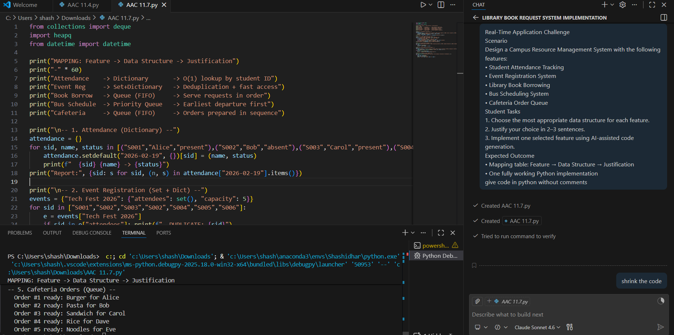  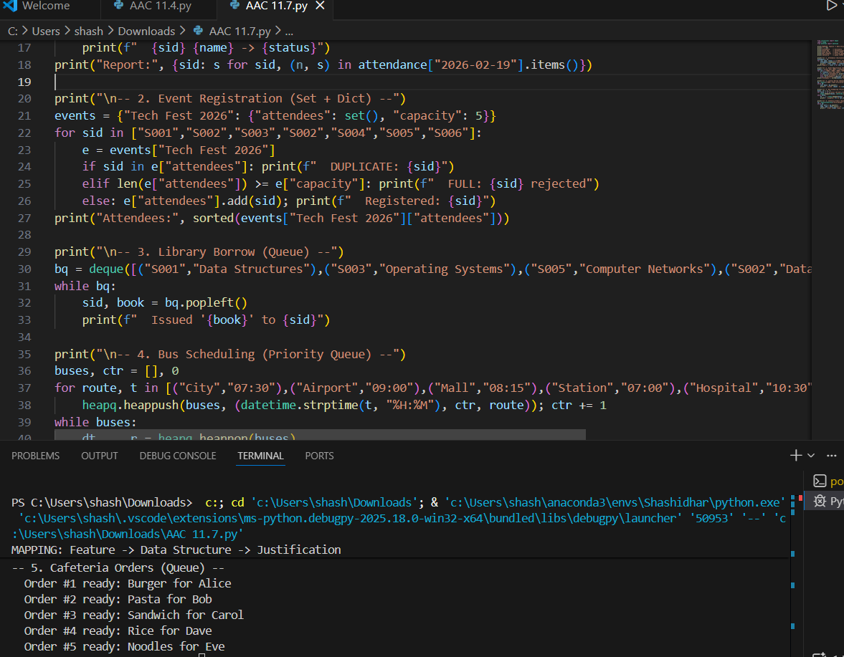  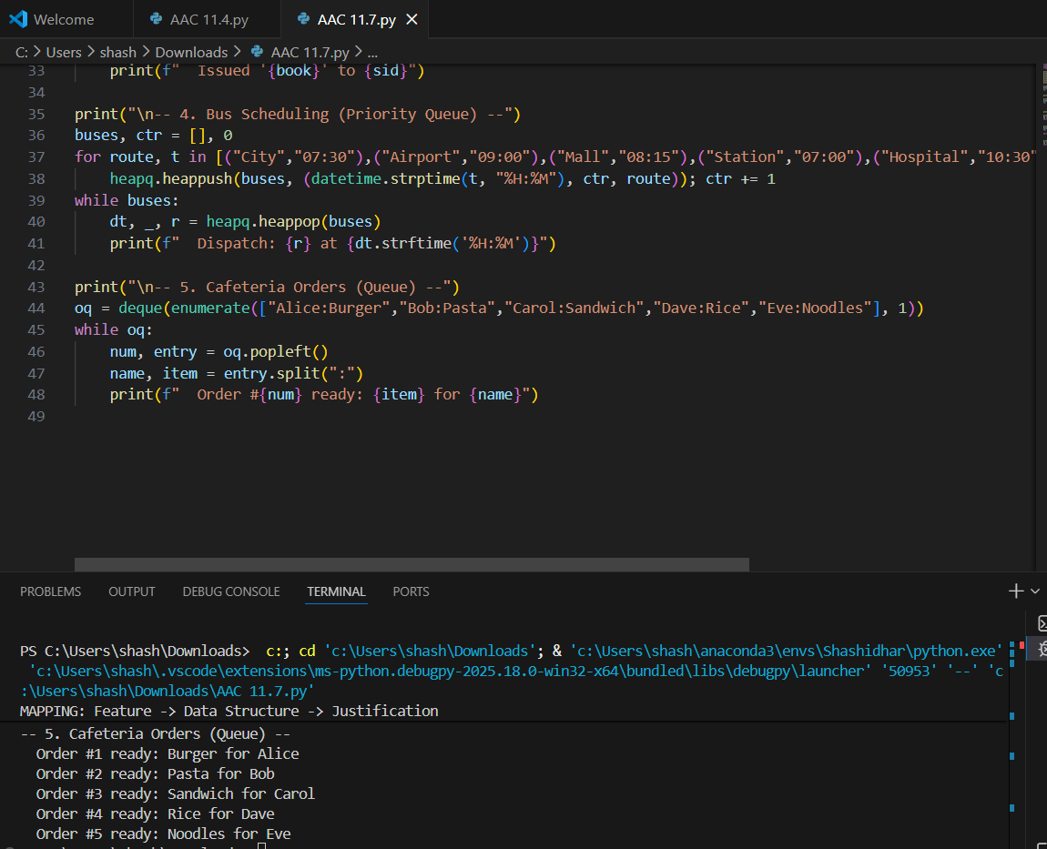  Note: Report should be submitted as a word document for all tasks in a single document with prompts, comments & code explanation, and output and if required, screenshots. |  |  |  |  |  | Week6 - Wednesday

